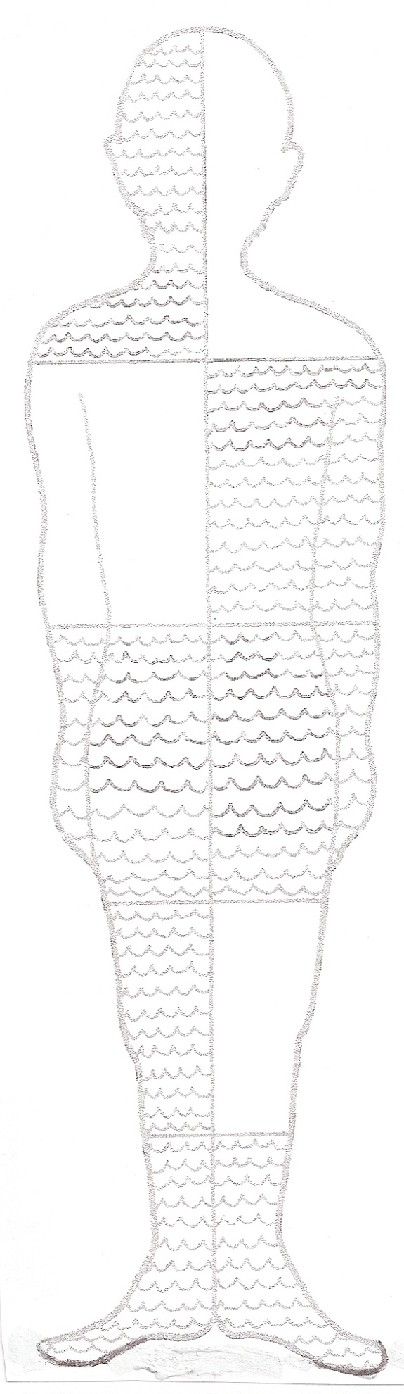

70% of the human body is water.

With a partner trace an outline of your body. Cut out the figure. Fold in half vertically then fold in half 3 times . Unfold. Color 7 of the 10 sections blue to represent 70% of the body.

Project Wet, Aqua Bodies. ©Watercourse and Western Regional Environmental Education Council.

71% of the Earth's surface is covered by water; 29 % is covered by land. Only 3% of that water is fresh water, the rest is saltwater.

